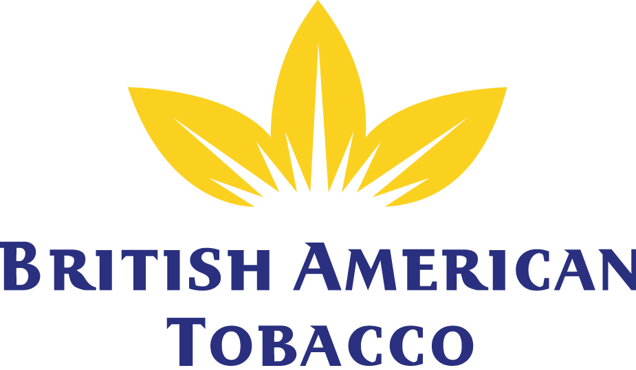

British American Tobacco
is currently seeking a candidate for the following roles:

Trade Marketing Representative
in Skopje, Tetovo and Gostivar area

Responsibilities:
- Visiting outlets according to route plan
- Sales management
- Payment discipline
- Contract negotiation with Independent & KA customers
- Cycle plan and Trade activities execution for DSS customers
- Implement brand and trade programmes in the outlets;
- Ensure the effective and efficient execution of marketing activities in the territory;
- Ensure the achievement of sales, distribution, availability and visibility objectives for the territory;
- Establish and develop business partnership with customers.

Key position requirements:
- University degree is required but not mandatory;
- Experience in selling to retailers, Wholesalers and Distributors in the Consumer Products industry is preferred
- Basic Excel and MS Office suite
- Driving license and driving experience;
- Knowledge in written and spoken English;
- The right attitude is crucial; successful candidates are: => Good team players
- Adaptive and fast learners
- Resilient to work in a dynamic environment
- Assertive in communication and negotiation style
- Proactive contributors to team results

Interested candidates are invited to submit their CV in English (including copy of all your academic records, diplomas & other certificates) to:

ALMAKO_Recruitment@bat.com
or to the address below no later than 16th of June 2020

Only the short-listed candidates will be contacted. Discretion is guaranteed.

TDR Skopje member of British American Tobacco

Address: Blvd 8th September No 18
Skopje

