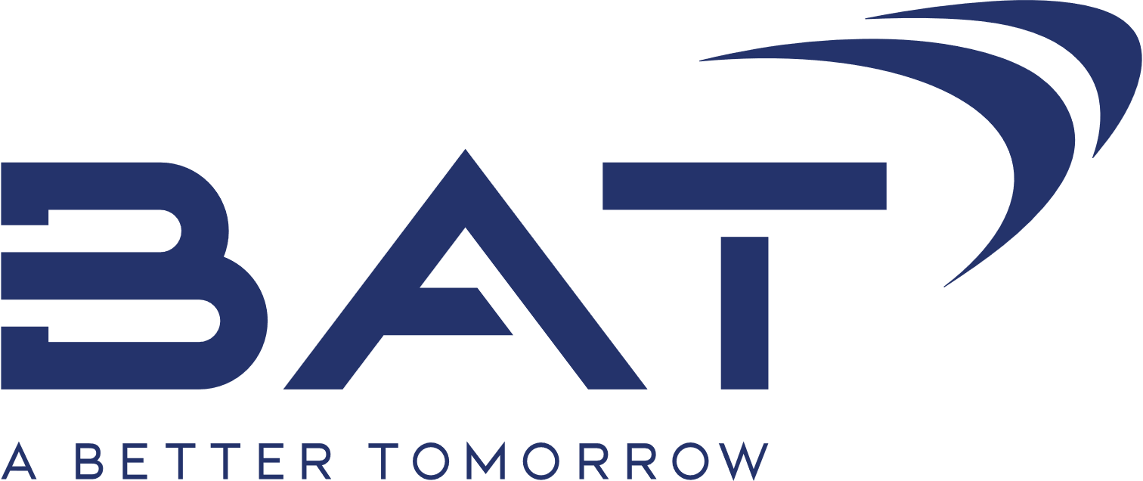

**HR Intern**

Welcome to the recruitment & selection process for BAT! We are a global leader with over 200 brands present in more than 200 different markets. Our company hires talented professionals from various fields, and we provide them working environment to explore their full potential.

That is why we APPRECIATE every initiative, SUPPORT enthusiasm, and REWARD the result of each of our employees.

If you want to be part of the team of one of the world's most desirable employers, send us your application!

**OUR EXPECTATIONS:**

* University degree - recent graduate or a final year student
* Excellent knowledge of English language
* Excellent knowledge of MS Office suite
* Strong time management skills—ability to prioritize and meet deadlines
* Proactive, dynamic, open-minded, ready to self-develop person
* Excellent analytical skills
* Positive and constructive attitude

**MAIN TASKS:**

* Participating in the recruitment process – posting job requisitions, managing relationship with third party recruitment partner, coordinating selection processes, planning, and organizing interview schedules
* Organizing and implementing Employer Branding activities in line with Company guidelines
* Participating in the organization of various company’s events
* Providing support in Employee administration processes
* Providing support in various HR projects
* Being responsible for other assigned duties during the programme

**WHAT WE OFFER:**

* Paid internship in duration of 6 months with the possibility for contract extension
* Experience how a multinational company operates
* Superb working environment with challenging tasks
* Young, vibrant, and dynamic team

**While we appreciate all the applications, please note that only short-listed candidates will be contacted.**

**READY TO KICK-START YOUR CAREER? APPLY NOW!**

[**ALMAKO_Recruitment@bat.com**](mailto:ALMAKO_Recruitment@bat.com)

Closing date for applications **12 December 2021**